Circuits with resistors, voltage and current sources
- Write your answers in the table shown on the next page. Write “unknown” in the entries where current/voltage cannot be determined (use when a value is infinite).
- On a separate page, show your work for each problem.
- Round you answer to 2-significant figures and include units.
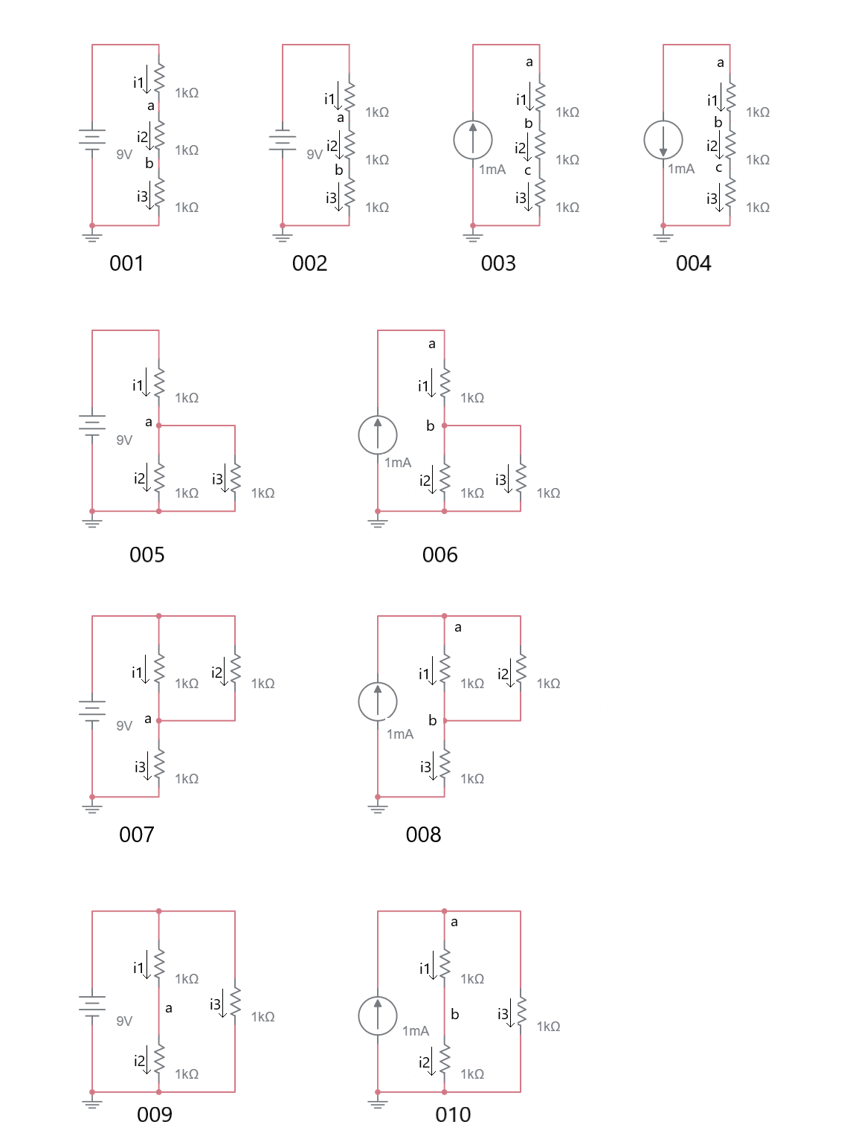
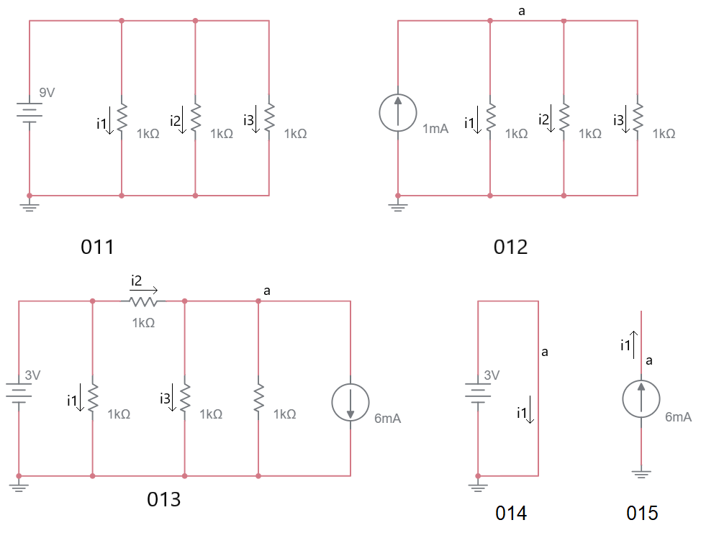

Circuit |  | a | b | c | i1 | i2 | i3
001
002
003
004
005
006
007
008
009
010
011
012
013
014
015

Circuits with resistors and capacitors
Plot all voltage across the capacitor and the current through the capacitor as a function of time. Assume that the capacitor is initially discharged; in other words, the voltage across the capacitor is 0V at time 0.
The symbol is a unit step voltage source that goes from 0V to 1V at time 0.
The symbol is a unit step current source that goes from 0V to 1mA at time 0.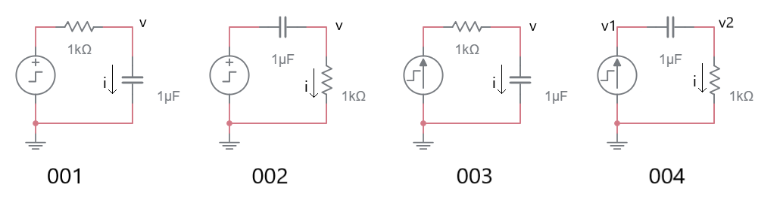

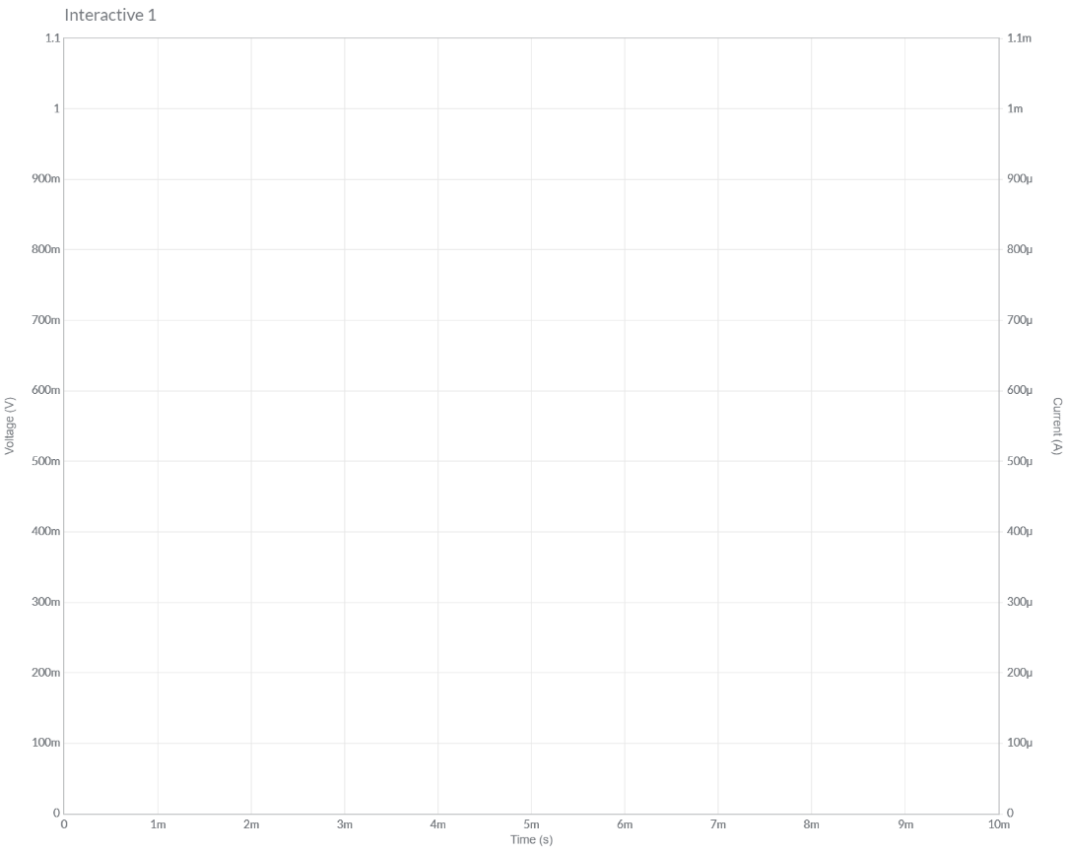
Plot the voltage and current for the circuit labeled 001.



Plot the voltage and current for the circuit labeled 002.

Plot the voltage and current for the circuit labeled 003.


Plot the voltage and current for the circuit labeled 004.

Multistage amplifiers and dependent sources
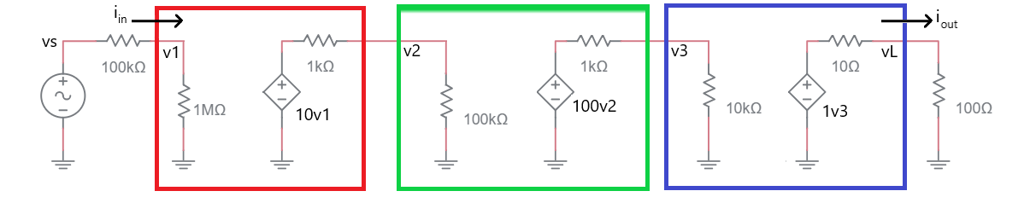
Determine the voltage gain v1/vs using the following steps

Step 0: Determine the gain v1/vs by examining the voltage divider formed by the source and the input to the first (red) stage.

Step 1: Determine the gain v2/v1 by examining the voltage divider formed by the output of the first stage (red) and the input to the second stage (green).

Step 2: Determine the gain v3/v2 by examining the voltage divider formed by the output of the second stage (green) and the input to the third stage (blue).

Step 3: Determine the gain vL/v3 by examining the voltage divider formed by the output of the third stage (blue) and the load resistor.

Step 4: Multiple the ratios from steps 0 to 3 together to fine the overall gain vL/vs.

Determine the current gain A_{i} = i_{out}/i_{in}

Step 1: Use Ohm’s law at the input to write an equation for i_{in} in terms of v1 and the resistance.

Step 2: Use Ohm’s law at the output to write an equation for i_{out} in terms of VL and the resistance.

Step 3: Use the previous two steps to write the ratio i_{out}/ i_{in} in terms of v1 and vL. These use the results from the previous section to arrive at a numerical value for the current gain.

Determine the power gain A_{p} = p_{out}/p_{in}
Use the previous two results to describe p = v*i for the output and input.

DC and AC simplifications for common circuit elements
As an engineer you will often need to make quick estimate of a circuit’s behavior. In these cases, it is completely appropriate to make approximations of component behavior to simplify the analysis.
Element | DC Model | AC Model
Resistor | R | R
Capacitor | Open | C
Inductor | Short | L
Voltage Source | V | Short
Current Source | I | Open

Practical Application – Coupling AC signal on a DC bias
The following circuit is very useful as it allows an AC signal to be DC biased at any level you need. In order to understand how this circuit operates, you will need to invoke the principle of superposition. Superposition dictates that the total response of a system is the sum of the partial response. A partial response is the contributions that one energy source has on the output while all the other energy sources are set to 0. So, in terms of the schematic given the total response is the sum of the partial response due to the AC source (with the 10V supply set to 0V), plus the partial response due to the DC source (with the AC source set to 0).

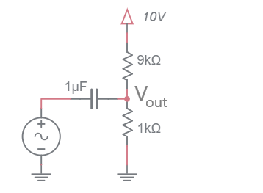
In this analysis, assume that the AC source is described by 0.5sin(6,280t), a 1V peak to peak 1kHz sine wave.
In the Draw the schematic row, draw the equivalent circuit for each source. For example:
- In the AC Source column draw the schematic with all components replaced by their AC equivalent model from the table in the DC and AC simplifications for common circuit elements section and setting the 10V supply to 0V.
- In the DC Source column draw the schematic with all components replaced by their DC equivalent model from the table in the DC and AC simplifications for common circuit elements section and setting the AC source to 0V.
In the Vout row, use circuit theory to determine the value of Vout.
In the Total Response row add together the AC and DC contributions.

 | AC Source (Set DC source to 0) | DC Source (Set AC source to 0)
Draw the schematic
Vout
Total Response

